14th June 2023

SAFEGUARDING LOW LEVEL CONCERN POLICY

ELITE ANGLO CHINESE SERVICES
SAFEGUARDING EMERGENCY CONTACT

Gwyn Phillips Designated Safeguarding Lead (DSL) and Prevent Lead
Tel + (44) 01428 648393
Mobile + (44) 07772 252303
Email: gwyn@eliteacs.com

Eve Leung Deputy Safeguarding Lead (DSL)
Tel + (44) 020 81442145
Mobile + (44) 07787 536030
Email eve@eliteacs.com

EMERGENCY CONTACT DETAILS
Name Eve Leung

Admin Address 33 Lower Road, Grayswood, Haslemere
Surrey, GU27 2DR
Telephone: UK Tel. + (44) 020 81442145
UK Mobile + (44) 07787 536030
Hong Kong + (852) 9530 8525
Email: info@eliteacs.com
Website: www.eliteacs.com

1. Introduction
At ELITE, we take safeguarding very seriously. This includes ensuring that adults who work with children do so in a way that is in accordance with the ethos and policies set out by the agency, including the Staff and Host Family Code of Conduct. This policy sets out the detail and processes for staff and volunteers regarding low-level concerns they may have.
2. Summary
It may be possible that an adult act in a way that does not cause risk to children, but is however inappropriate. A member of staff or volunteer who has a concern about another adult should inform the DSL about their concern using a Low-Level Record of Concern Form. If the DSL cannot be contacted, the Deputy DSL should be contacted instead.
3. Keeping Children Safe in Education September 2021
The following is taken from Keeping Children Safe in Education September 2021
407. As part of their whole school approach to safeguarding, schools and colleges should ensure that they promote an open and transparent culture in which all concerns about all adults working in or on behalf of the school or college (including supply teachers, volunteers and contractors) are dealt with promptly and appropriately.
408. Creating a culture in which all concerns about adults (including allegations that do not meet the harms threshold (see Part Four - Section one)) are shared responsibly and with the right person, recorded and dealt with appropriately, is critical. If implemented correctly, this should encourage an open and transparent culture; enable schools and colleges to identify concerning, problematic or inappropriate behaviour early; minimise the risk of abuse; and ensure that adults working in or on behalf of the school or college are clear about professional boundaries and act within these boundaries, and in accordance with the ethos and values of the institution.
What is a low level concern?
409. The term ‘low-level’ concern does not mean that it is insignificant, it means that the behaviour towards a child does not meet the threshold set out at paragraph 338. A low-level concern is any concern – no matter how small, and even if no more than causing a sense of unease or a ‘nagging doubt’ - that an adult working in or on behalf of the school or college may have acted in a way that:
• is inconsistent with the staff and host family code of conducts, including inappropriate conduct outside of work; and
• does not meet the allegations threshold or is otherwise not considered serious enough to consider a referral to the LADO.
410. Examples of such behaviour could include, but are not limited to:
- • being over friendly with children;
- • having favourites;
- • taking photographs of children on their mobile phone;
- • engaging with a child on a one-to-one basis in a secluded area or behind a closed door; or,
- • using inappropriate sexualised, intimidating or offensive language.
411. Such behaviour can exist on a wide spectrum, from the inadvertent or thoughtless, or behaviour that may look to be inappropriate, but might not be in specific circumstances, through to that which is ultimately intended to enable abuse.
412. It is crucial that any such concerns, including those which do not meet the harm threshold (see Part Four - Section one), are shared responsibly and with the right person, and recorded and dealt with appropriately. Ensuring they are dealt with effectively should also protect those working in or on behalf of schools and colleges and guardian agencies from potential false allegations or misunderstandings.
4. Clarity around Allegation vs Low-Level Concern vs Appropriate Conduct
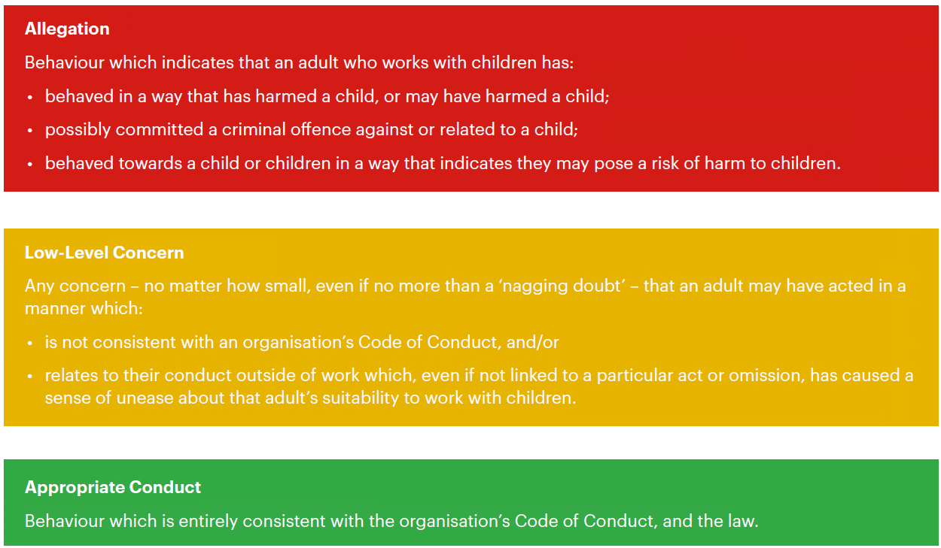
5. Storing and use of Low-Level Concerns and follow-up information
LLC forms and follow-up information will be stored securely within agencies safeguarding systems, with access only by the DSL and Deputy DSL. This will be stored in accordance with the agencies GDPR and data protection policies.
The adult(s) reporting the concern must keep the information confidential and not share the concern with others apart from the DSL and/or the Deputy DSL
Low-Level Concerns will not be referred to in references unless they have been formalised into more significant concerns resulting in disciplinary or misconduct procedures.

